## Sticky Notes

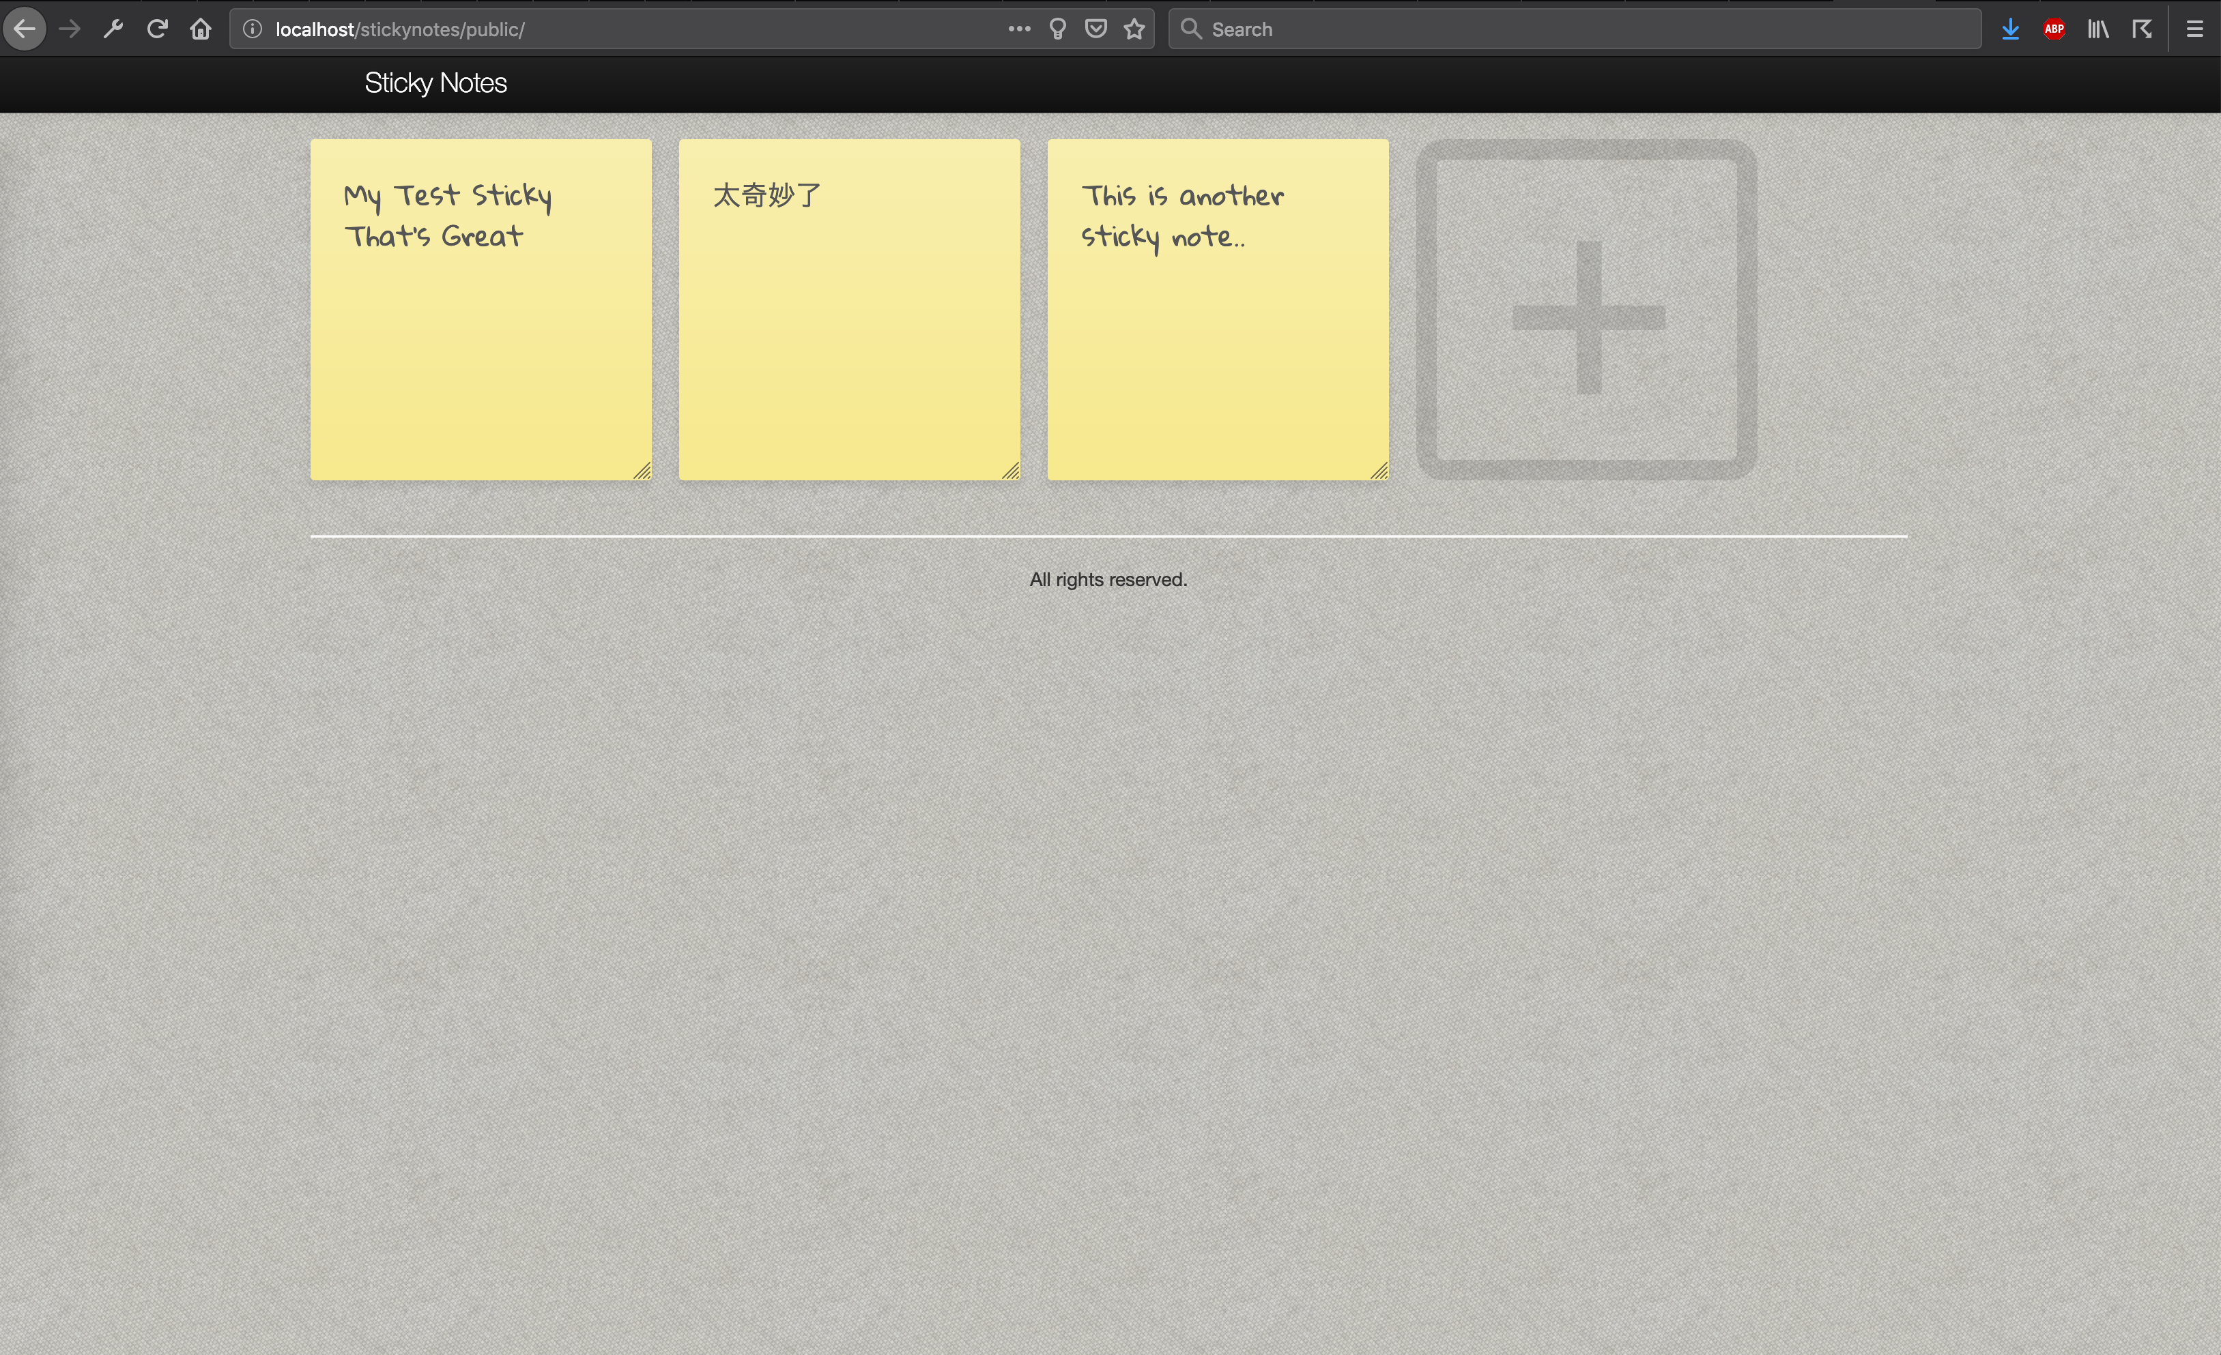

Sticky Notes is simple web application built on Zend Framework 2 and uses  
the ZF2 MVC layer and module system. This simple application is an extension to  
the skeleton application provided by Zend Technologies.

* It is doing all CURD operations using AJAX call.
* Also it supports multilingual UI.
* Usage Bootstrap, JQuery, HTML5